**Data-Driven Insights for Digital Marketing Campaigns**

**~ SRITHIKAA TAMILSELVAM - BA&DM – GUVI Geek networks**

**Main Assumptions of the Project:**

--- Random data points given

--- Different campaigns’ results of one factor – given in multiple sheets to focus on one characteristic

--- Some of the derived data points – do not seem to relate to each other within the table itself.

--- In this dataset given where there are users and new users, we categorize them into the ideology that:

**Users – In totality means:**

The total number of **unique visitors** who visited your website during the time period (includes both returning and new users).

**New Users:**

The number of **first-time visitors** to your site (they’ve never been to the site before — tracked by cookie/device).

New Users ≤ Users

So, if you see data points where it says: (e.g)

| **Channel** | **Users** | **New Users** |
| --- | --- | --- |
| Direct | 49,150 | 46,784 |
| Organic Search | 7,955 | 6,838 |

So:

* Direct had **49,150 total users**, and out of them, **46,784 were new**.
* That means **2,366 users were returning visitors**.

THEREFORE: the analysis is done for the users in totality in the Traffic Acquisition sheet which talks about the dataset in general that is about the people in general that consists of new, existing / returning and the second sheet User Acquisition, specifically deals with new users. Analysing both provides a complete funnel view: **from first click to final conversion**.

**---- Note on:**

**Irregular Landing Page Entries –**

**--- one cell has the entry of this sort in the landing pages sheet in the landing page column**

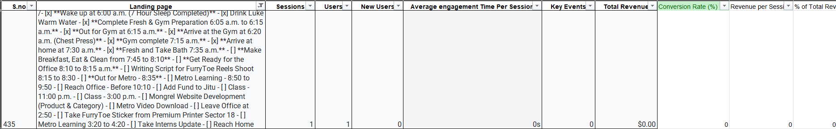

**Example:**  
/ **Wake up at 6:00 a.m. (7 Hour Sleep Completed) ** …

This is an unusual page landing entry that could resemble **auto-generated titles or user journal logs** rather than standard URLs. This sort of entry has appeared only once in the dataset and:

* Have **zero revenue and negligible engagement**.
* May be the result of **improper GA tracking**, such as:
  + Logging dynamic titles as paths.
  + Capturing non-website content (e.g., notes, docs).
  + Test or internal pages exposed to tracking.

These are some of the reasons for it to have been input into the dataset while retrieval of data from the platform.

As for this entire analysis, this type of data hasn’t affected the process for analysing. Due to these factors, it did not track the results well since it says that it has generated low or no results that are required for analysis in terms of revenue, sessions and so on and so forth. But it would be necessary to remove or exclude based on the requirement of analysis objective as they do not represent meaningful user behaviour or actionable insights However, they were documented here for transparency and future audit reference.

/ --- just a slash would mean that:

The user landed on the **homepage** of the website. Users typing your domain directly or clicking home-linked ads/emails arrive here. It is the main entry point as well.



Note on “(not set)” Landing Pages:

This typically indicates:

* **Missing or broken tracking** in Google Analytics.
* Users entered through **undefined routes** (e.g., links without UTM tags, redirects, or app traffic).
* **System errors** where the page path wasn't recorded.

--- It still matters due to the following reasons:  
Although “(not set)” entries can’t be directly attributed to specific landing pages; they still reflect **real user sessions** and contribute to overall traffic. I had retained the “(not set)” entries in analysis to account for total session volume. But when necessary where needed, decisions can be taken to exclude this entry.



Datasets in each sheet in the workbook, have been cleaned and the data types and formatting have been set up using excel and the analysis is predominantly done only using excel for both analyzing and for visual representation of the insights.

--- Duplicates and Null Values – the datasets given are all having few columns with duplicates and few columns with null values but it wouldn’t be logical to remove them because a 0 is also something in this dataset’s context, which means, no result has been generated in whatsoever context it is off to be like. Hence NOT removing duplicates and handling null values by replacing – coz it would then make no sense because it wouldn’t be accurate and real for many parts of analysis. But if there is a need, we can always remove it manually based on the required objective while analyzing.

**FORMULAS USED FOR ANALYSIS:**

**Cost per Engaged Session = Cost / Engaged Sessions**

**Revenue per User = Total Revenue / New Users**

**CTR (%) = (Key events/ Impressions) * 100**

**CPC = Total spend/ Key events**

**ROI (%) = (Total Revenue – Total Cost / Total Cost) *100**

**Conversion Rate (%) = (Key Events/ Engaged Sessions) * 100**

**ANALYSING THE GIVEN DATASETS:**

SETTING UP KPIS’:

**What are KPIs?**

KPIs are important **metrics** that tell you how well your marketing efforts are performing.

Google Analytics gives us **raw metrics** like sessions, users, revenue, etc., but to make **smart decisions**, we need to **calculate custom KPIs** that help answer questions like:

--- Which traffic source gives the most return for the money we spend?

--- Which source gives us the most engaged users?

--- Are we spending too much on a low-performing channel?

ANALYSIS:

**-1.USER ACQUISITION:**

KPI’s for sheet 1: - user acquisition:

**--- Cost per Engaged Session - This tells us:**

How much are we spending to get one engaged session?

**FORMULA: Cost per Engaged Session = Cost / Engaged Sessions**

Lower is better: it means we’re spending less for every active user.

**--- Revenue per User - This tells us:**

How much revenue are we earning per new user acquired?

**FORMULA: Revenue per User = Total Revenue / New Users**

Higher is better: it means each user is generating more money.

|  |  |  |
| --- | --- | --- |
| **First user primary channel group (Default Channel Group)** | **Cost per Engagement** | **Average Revenue Per User** |
| **Direct** | $0.01 | $0.02 |
| **Organic Search** | $0.02 | $0.41 |
| **Referral** | $0.05 | $0.21 |
| **Paid Search** | $0.06 | $1.35 |
| **Organic Social** | $0.01 | $0.00 |
| **Organic Shopping** | $0.10 | $0.00 |
| **Organic Video** | $0.00 | $0.00 |
| **Cross-network** | $0.05 | $0.00 |
| **Email** | $0.00 | $0.00 |

# **Insights:**

**1.Direct Traffic – High Volume, Low Efficiency:**

The Industry Benchmark for most websites, engagement rates between **20–50%**(approx.) from direct traffic are fairly average. Direct traffic brought the highest number of new users **(46,784)** and engaged sessions **(30,540)**, but the engagement rate is only **37.85%**, and revenue per user is just **$$0.02**. So, **37.85% is neither too low nor impressively high—right in the middle**. This suggests strong awareness but weak intent — landing page or CTA optimization may help.

**2.Referral – Best Performing Channel:**

With only **1,925 new users**, Referral traffic delivered **117.74% conversion rate**, **$0.21 revenue per user**, and **72.85% engagement rate**, all with a **$0.05 cost per engagement**. A **high-value channel** worth scaling via partnerships or backlinks.These metrics signal that users arriving from partner websites or backlinks are highly intentional and valuable, making this a priority channel for scaling partnerships.

**3. Organic Shopping – Great Engagement, But Zero Revenue:**

Despite an **89.15% engagement rate** and **CTR of 121.01%**, this channel had **$0 revenue**. Indicates a **strong interest but broken conversion funnel** — must improve **product visibility or checkout experience**. Looks like even existing customers haven’t made a single purchase. There is a clear disconnect between the user’s interest and actual purchase this could be due to a lot of reasons one of few which I believe could be the idea of entering the site initially and while it moves towards purchasing there must mismatch issue, could be that people did not get satisfied with what they came for looking in the first place to what they actually found in it, pricing mismatch, product confusion, extremely weak checkout UX - that needs urgent attention before investing further in this micro-channel.

**4. Organic Search – High-Intent and Profitable:**

Generated **$2,811.96 revenue** from **6,838 users**, with **67.21% engagement** and **highest ROI of 2236.87%**. This is an **efficient SEO source** to prioritize and scale with more content and optimization because it shows that this channel is the most efficient and profitable SEO channel. Continued investment in content optimization and keyword strategy can help sustain and grow this winning source.

**5. Paid Search – Low Engagement, Moderate Returns:**

Though it earned **$888.01** and had **$1.35 revenue per user**, the **engagement rate was only 22.63%**. ROI was **0.00%**, showing break-even performance — the low interaction suggests ad fatigue, misaligned targeting, or weak landing content, and while it does convert, the current setup doesn’t scale efficiently. Campaign refinement is needed for profitability**.**

**6. Organic Social – Engaging but Not Converting:**

Strong **69.84% engagement rate** and **52.68% CTR**, yet **$0 revenue** and **-100% ROI**. Good at attracting attention, but fails to convert — likely needs better **offers, targeting, or tracking fixes**.

**7. Organic Video – Not Enough Data to Judge:**

This channel had only one user and zero measurable performance, making it statistically insignificant. While it shows 100% CTR, the absence of sessions, engagement, or revenue indicates this was likely a test run. If relevant, further data should be collected before making decisions.

**8. Cross-Network – No Performance:**

With just one user, zero engagement, and no revenue, Cross-Network marketing is currently non-performing. Given its -100% ROI, the channel should be paused until a revised strategy or clearer use case is defined. This seems to be same like the organic video channel.

# **Talking about the created KPIs:**

All of these could be individually scrutinised but to make it easier for understanding I have focused on the main metric that each channel is measured against to get an understanding of the functioning of the channels. Note: each channel has its own metric of measuring.

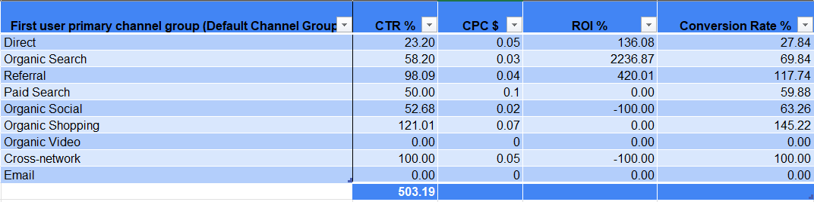

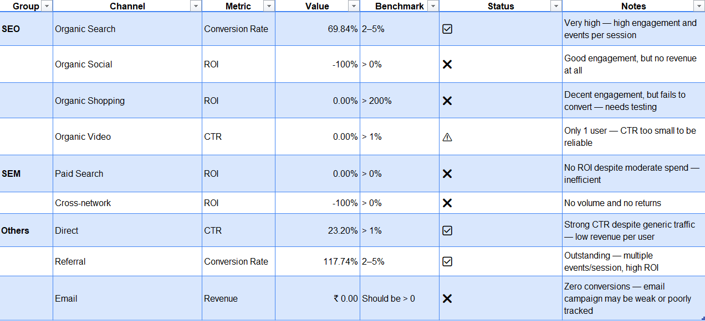

The **Direct** channel overwhelmingly leads in new user acquisition, bringing in **46,784 users**, while all other channels trail significantly behind. This suggests a strong existing brand presence or offline promotion that's driving users directly to the website. However, channels like **Organic Search** and **Referral**, while lower in user count, still contribute some meaningful new users and could be optimized for further growth. Channels such as **Email**, **Paid Search**, and **Organic Social** are currently underperforming in terms of new user acquisition. **Implication**: Focus on maintaining and enhancing Direct and Organic Search efforts. Investigate underperforming channels like email for missed opportunities.

* **Direct** traffic contributed the **highest number of new users** (46,784), making it the strongest acquisition source.
* **Organic Search** brought in **6,838 new users**, showing the effectiveness of SEO.
* Channels like **Paid Search**, **Referral**, and **Organic Social** contributed moderately (below 2,000 users).
* Channels like **Email**, **Organic Video**, and **Cross-network** showed **no new user generation**, possibly due to inactive or ineffective campaigns.

This chart reveals that Organic Search delivers the highest revenue **($2811.96)** with zero cost, making it the most cost-effective and high-performing channel. Direct and Referral also generate notable revenue **($1003.59 and $396.25 respectively),** though Direct comes at a cost of **$425.10**. Surprisingly, email marketing, despite having no associated cost, is generating no revenue, indicating a need to reassess its strategy of targeting. Channels like Paid Search and Organic Shopping show minimal returns, suggesting they are either underfunded or misaligned with the audience. **Implication**: Consider **scaling up Organic Shopping and Direct**, pause or restructure **Paid Search & Organic Social**, and audit Email and Organic Search campaign strategies

**-2. TRAFFIC ACCQUISITION:**

KPI’s for sheet 2: -

* **CTR**
* **CONVERSION RATE**
* **REVENUE PER USER**

**NOTE: THE SAME FORMULA TYPED IN FOR THE KPIS’ CALCULATED FOR, IN SHEET 1 ARE APPLIED HERE TOO.**

# **Insights:**

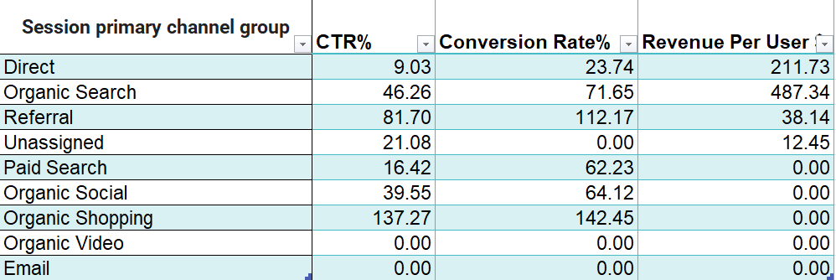

**1.Organic Search is the top overall performer:**

With a **CTR of 46.26%**, **conversion rate of 71.65%**, and **highest revenue per user ($487.34)** — Organic Search proves to be the most effective channel in terms of attracting and converting users in totality – including both new and existing users.

**2.Organic Shopping drives huge engagement but $0 revenue:**

Organic Shopping has the **highest CTR (137.27%)** and **conversion rate (142.45%)**, yet **no revenue generated**. This may indicate missing conversion tracking or users taking non-revenue actions (like browsing or wish list) or it could also be the case that the payment page could have technical issues that are in need to be fixed or that what people come in search for doesn’t get fully satisfied of what they actually want to acquire when they see the shopping page. It is interesting to note that it is not just a case with the new users but also existing users do not seem to be making any purchase that converts into revenue for the business as such. This could be also understood through the previous section where user acquisition is discussed.

**3.Paid Search shows engagement, but not performance**

Although Paid Search has a **CTR of 16.42%** and **62.23% conversion rate** by showing a decent user interest it fails to deliver ROI, it generated **$0 revenue**, making it an **inefficient investment** without return. This indicates potential mismatches in ad targeting, ineffective landing pages, or broken conversion tracking or audience targeting should be reviewed.

**4.Direct and Referral are both strong contributors**

Direct traffic users convert well (**23.73%**), with a **high revenue per user of $211.73,** this could imply brand familiarity and trust. Referral users have very high engagement **(CTR 81.69%)** and conversion rate **(112.17%)** and typically shows a hidden strength, although revenue per user is moderate **($38.14)**, the amount of engagement suggests it’s a channel worth scaling.

**5. Ineffective Channels Despite User Interest**

Channels like Organic Social, Video, and Email are non-converting despite visible engagement, indicating either insufficient targeting, weak offers, or tracking gaps — these should be deprioritized or fixed.

---- Based on the validation against performance benchmarks, SEO channels like Organic Search deliver strong results, especially in revenue per user. However, Organic Shopping, despite having excellent conversion rates, shows no revenue, likely due to tracking issues. SEM channels (Paid Search and Unassigned) are the weakest, showing no return despite user engagement. Referral and Direct channels in the "Others" group show high potential and consistent behaviour across both acquisition views. ----

**Insights based on the derived KPIs’:**

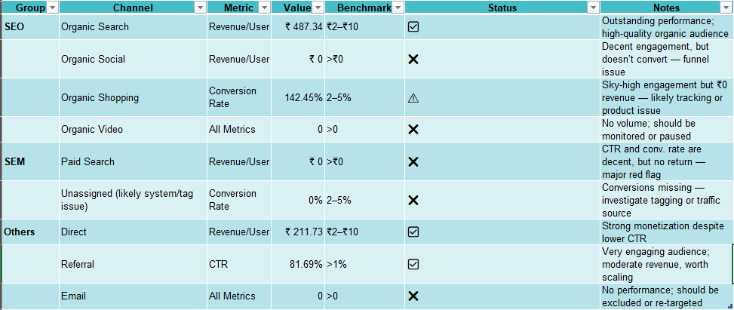

**Organic Shopping** has the highest engagement rate at **96.36%**, followed by **Referral** (72.83%) and **Organic Search** (64.57%), indicating these users are not just arriving but actively interacting with the content. Interestingly, **Email** and **Unassigned** channels show **0% engagement**, which is a red flag suggesting poor quality or irrelevant traffic. Despite bringing in the highest new users, **Direct** has a relatively low engagement rate (**38.06%**), showing that while users come directly, they may not explore much.

This scatter plot shows no clear correlation between the number of **events per session** and the **engagement rate**. In fact, some sessions with very high interaction counts (close to 70 events) show **lower engagement rates**, implying that beyond a point, more interactions don't necessarily translate to better engagement—possibly due to irrelevant or repeated actions rather than quality content consumption.

**Organic Search** is again the top revenue contributor (**$2811.96**), validating its strength not only in engagement but also in ROI. **Direct** and **Referral** follow with **$1003.59** and **$396.25**, respectively. Channels like **Organic Shopping** and **Paid Search**, although not leading in revenue, contribute moderate amounts, whereas **Organic Social**, **Email**, and **Video** drive **zero revenue**, highlighting areas needing reevaluation or strategic changes.

**-3. EVENTS SHEET:**

**KPI FOR THIS SHEET:**

**---- % OF TOTAL EVENTS = Each Event/Sum of events (note: not frequency but the totality – sum)**

**It tells us how much each event contributes to the overall user activity on the website.** Instead of just raw counts, it answers:

“Out of everything users did on the site, how much of that activity was THIS particular event?”

|  |  |  |
| --- | --- | --- |
| **Event Name** | **Event Count** | **% of Total Events** |
| page_view | 1,16,103 | **20.14%** |
| session_start | 87,590 | **15.19%** |
| view_promotion | 75,812 | **13.15%** |
| predicted_top_spenders | 58,504 | **10.15%** |
| top_spenders | 58,504 | **10.15%** |
| first_visit | 56,665 | **9.83%** |
| view_item_list | 45,050 | **7.81%** |
| user_engagement | 25,706 | **4.46%** |
| new_recent_active_user | 18,713 | **3.25%** |
| view_item | 13,764 | **2.39%** |
| select_promotion | 8,749 | **1.52%** |
| select_item | 3,030 | **0.53%** |
| new_engaged_user | 2,831 | **0.49%** |
| scroll | 1,074 | **0.19%** |
| add_to_cart | 1,066 | **0.18%** |
| san_francisco_users | 929 | **0.16%** |
| view_cart | 830 | **0.14%** |
| non_purchasers | 735 | **0.13%** |
| begin_checkout | 294 | **0.05%** |
| remove_from_cart | 195 | **0.03%** |
| add_shipping_info | 136 | **0.02%** |
| add_payment_info | 131 | **0.02%** |
| view_search_results | 42 | **0.01%** |
| purchase | 18 | **0.00%** |
| add_to_wishlist | 4 | **0.00%** |
| errors | 3 | **0.00%** |

# **Insights:**

**1. Page views and session starts dominate user activity:**

The page_view event accounts for **20.14% of total events**, followed by session_start (15.19%) and view_promotion (13.15%). These indicate users are **browsing a lot**, but not necessarily progressing to conversion-related actions.

**2. Only 1 event generates revenue — purchase:**

Out of **5,76,475 total events**, only **18 purchases** were recorded, contributing **100% of the revenue** ($5,069.81).  
But then this shows a **very low conversion rate**, despite high engagement. A major drop-off is occurring **after engagement but before purchase**. So, this essentially almost confirms that there could possibly be issues with respect to the UX of the **interface, mismatch** of pricing, payment related issues on the company’s side, etc like I have mentioned in the user acquisition and as well as the traffic sheets

**3. Add to cart and checkout events are very low:**

* add_to_cart: only 1,065 events (~0.18% of total)
* begin_checkout: just 294
* add_payment_info: only 131

This means users are **interacting** but **not progressing** down the funnel — a sign of either poor UX, pricing issues, or lack of purchase intent.

**4. Top spender predictions show high repeat actions:**

Events like predicted_top_spenders and top_spenders have **very high Event Count per User (54)**, but **$0 revenue**.  
These users engage frequently — they are ideal for **retargeting or special campaigns**, but currently aren’t converting, but again all the issues could be intertwined, at the end of the day we need people to purchase and so we would be able to acquire revenue and thus is the concept of business and the objective of the ads that we run.

**5. Scroll, select item, and view item are active but shallow:**

Engagement events like scroll, view_item, and select_item happen fairly often, but **don’t lead to checkout or purchase**. This shows content may be **attracting curiosity but not trust or urgency** to buy.

The Events analysis reveals a wide engagement funnel with a sharp drop at the conversion stage. This highlights the need to optimize mid-to-bottom funnel elements like product pages, CTAs, and checkout flows.

Despite a range of user actions tracked—like **add_to_cart**, **begin_checkout**, **view_item_list**, and more—**only one event contributes actual revenue**, while all others show **$0 revenue**. This indicates a severe tracking issue, funnel dropout, or that conversions aren't being attributed to specific user behaviors properly. Given that **page_view** and **session_start** dominate in volume, aligning these interactions with meaningful outcomes (like checkout or purchases) is essential for improving ROI and attribution clarity.

The most frequent user event is **page_view (29%)**, followed by **session_start (22%)** and **view_promotion (19%)**, showing that users are actively browsing and initiating sessions, with a fair level of interest in promotional content. Events like **predicted_top_spenders** and **top_spenders** each make up **15%**, suggesting that while the system is identifying high-value users, these users might not be progressing toward conversions or purchases—pointing to a potential drop-off later in the funnel.

**-4. LANDING PAGE SHEET:**

KPIs calculated were:

* conversion rate
* revenue per session
* % of total revenue

**NOTE: ALL OF THESE FORMULAS ARE THE SAME ONES THAT WERE USED IN THE PREVIOUS SHEETS’ ANALYSIS.**

**The analysis for this page is ideally done by using filters and formulas and rules to retrieve the data points that satisfy the required objective of analysis. So based on the retrieval we have gotten the following insights:**

**1.Top Traffic Pages (Sessions Top 10–15):**

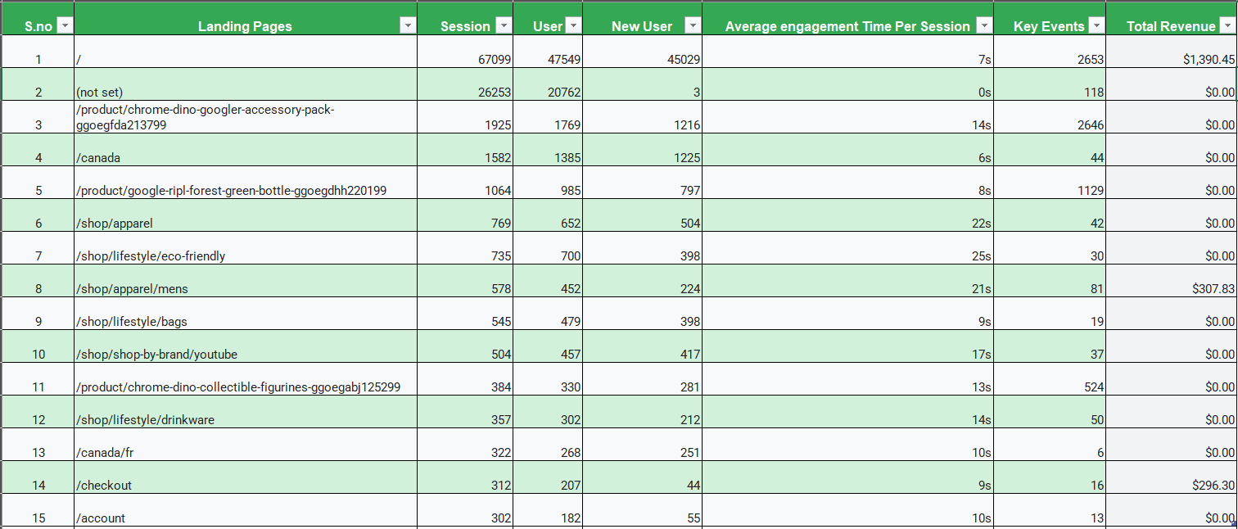

These pages receive the highest volume of sessions, making them critical entry points into the website. However, not all of them translate this visibility into conversions or revenue. Pages like /, /not set, and /canada bring in a large number of users, but have either low conversion rates or zero revenue. These pages need deeper UX and CTA optimization to ensure their traffic is monetized effectively.

**2. High Revenue Pages (Total Revenue > 0)**

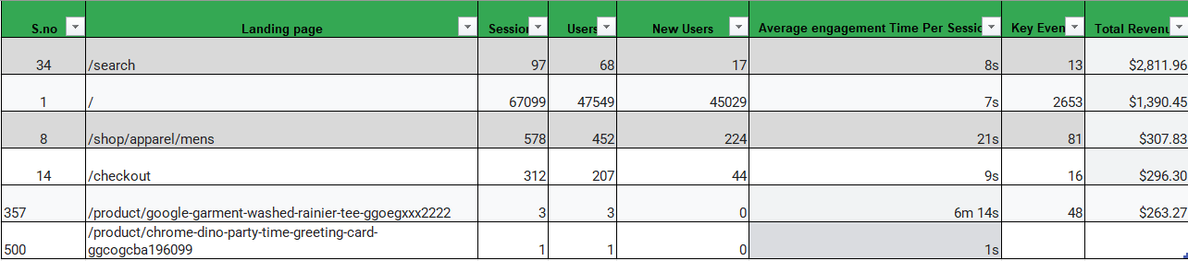

The few landing pages generating revenue — such as /shop/apparel, /checkout, and the homepage / — are essential for driving business value. Though traffic may not always be the highest, their ability to convert into revenue justifies increased promotion, SEO focus, and possibly retargeting ad spend. Their layouts and funnel structure should be studied and replicated on other low-performing pages.

**3. High Conversion Pages (Conversion Rate > 10%)**

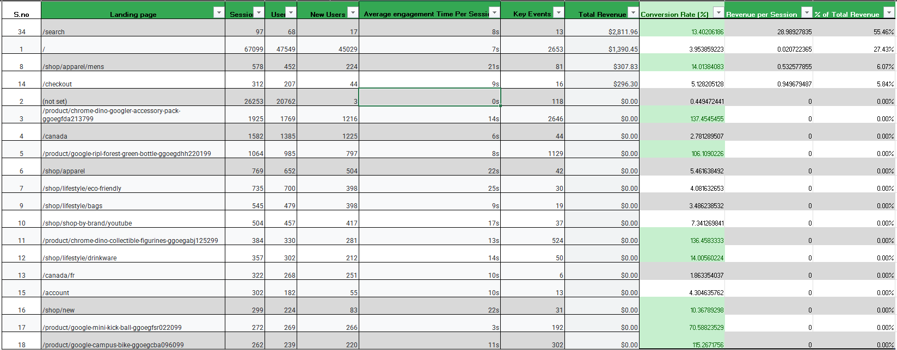

A small group of product pages, such as the Chrome Dino and Forest Green Bottle pages, have exceptionally high conversion rates (>100%). While they show strong user engagement and event triggers, they contribute no direct revenue. These pages should be reviewed for monetization leakage — either improving the checkout process or ensuring events lead to sales.

**4. Low-Performing Pages (Sessions > 1000, Revenue = $0)**



Several landing pages attract substantial traffic yet yield no revenue. Same goes here too but if we notice - The landing pages for the 'Chrome Dino Googler Accessory Pack' and 'Forest Green Bottle' show exceptionally high conversion rates (137% and 106% respectively), indicating strong user interaction. However, both generated $0 revenue. This suggests that while these pages are engaging users effectively, they are failing to convert that engagement into sales. These pages may suffer from issues such as low purchase intent, unclear navigation, or weak CTAs. These pages are strong candidates for funnel optimization — particularly around checkout flow, pricing, or CTA clarity.

The industrial bench mark for these metrics could vary but, on an average, as of 2024 it has said to be as follows:

Sessions: **500+**

Key Events: **100-200 or more**

Average Engagement Time Per Session: **30s – 1min and more**

Conversion rate: **1–3% = average**, **3–5% = strong**, **>5% = excellent**

Revenue per session: **Greater than 1$**

[Note: All these benchmarks are just the approximates but not the definitely sure set levels for determining the performances.]

There aren’t pages that satisfy all the metrics, but at the end of the day we need the revenue and if that is good it also invariably means that all the factors are pretty decently performed so here, the main metrics that we got to focus here is that if the revenue per user is greater than or equal to 1$ here are the following 2 pages:



The landing page with the most sessions by far is marked as **“(not set)”**, accounting for over **67,000 sessions**, which suggests a tracking or tagging issue in the analytics setup. This should be investigated, as it hides valuable insight into actual high-traffic pages. Apart from this, specific product-related pages like **"/shopby/image/4"**, **"/canada"**, and **"/dino-google-accessories"** show comparatively fewer sessions but still stand out as meaningful entry points. Ensuring these pages are well-optimized is crucial since they serve as users' first impressions.

This analysis highlights several pages with **very high conversion rates (above 100%)** but **zero recorded revenue**, indicating successful user actions like signups or cart adds that aren’t translating into transactions. Pages like **“/products/google-campus-bike-gogglesb030509”** and **“/shopby/age/6-to-8”** show particularly high conversion efficiency. The lack of revenue could stem from tracking gaps, checkout issues, or possibly conversions that don’t involve direct revenue (e.g., form submissions or trial signups). These pages deserve deeper funnel analysis and possibly revenue attribution fixes.

**-5. RETENTION SHEET:**

**In the given picture, the following was observed:**

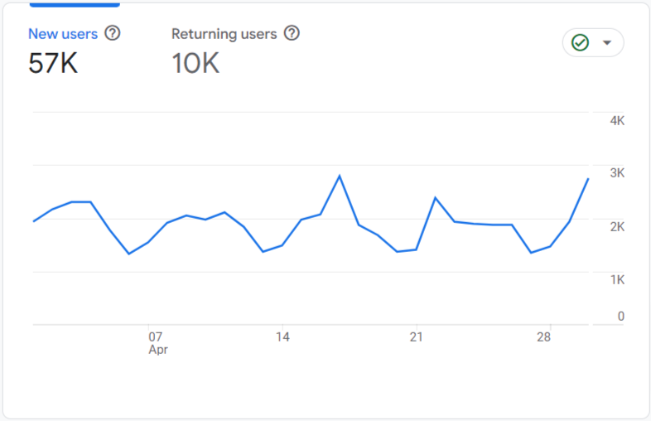

* **New Users**: 57,000
* **Returning Users**: 10,000
* A daily trend line showing returning users' activity from April 1 to April 30.

**Insights:**

The new users of 57000 people basically implies that the site is great at acquiring new users which in turn implies that the marketing reach work that the business is implementing is working pretty well.

Out of that only 17.5% of people are returning users (10k), this indicates a low user retention because the benchmark for user retention on an average for any industry lies above 30% approx. [this can change based on industry to industry, since here we do not know what exactly is this campaign for, assuming it is an ecommerce related business on an average of above 30% will be a good deal]. There is a noticeable drop-off between spikes. Should strengthen the strategies for increasing engagement of both new users and to bring in returning users.

Trend line predominantly shows an inconsistent user intent – there are some spikes around the mid of the month but it dips after. This could suggest that there should be a consistent engagement and positive persuasion strategy that must keep going to bring in new people through email marketing, loyalty programs, personalised experiences for existing users, etc.

**-6. AUDIENCE SHEET:**

The KPI created for this sheet was:

**---- Revenue per user $: Total revenue/Total no. of Users**

|  |  |
| --- | --- |
| **Audience name** | **Revenue Per User** |
| Non-purchasers | $0.00 |
| Predicted 28-day top spenders | $0.00 |
| Top spenders: Top 5% of users | $0.00 |
| Added to cart & no purchase | $0.00 |
| All Users | $0.08 |
| Users in San Francisco | $0.11 |
| Recently active users | $0.28 |
| Likely 7-day purchasers | $1.11 |
| Engaged Users | $1.86 |
| Purchasers | $241.42 |

**Insights:**

**1.High Revenue but Small Segment:**

Although the 'Purchasers' group includes only 21 users, they generated $5,069.81, implying $241.42 is the revenue per user and that seems to be pretty good returns, this is assuming that the investment for the campaign was a decent amount and that generated good returns in the form of purchase by the customers — which could potentially also be the full revenue from the campaign. This emphasizes the critical value of converting even a small number of users.

Also, it is noteworthy that the out of the 21 users all of them were only existing customers who had made the purchase, so it should be figured out why the new users aren’t purchasing and also should engage in strategies such as discounts personally sent via emails, or price drop strategies, etc to persuade them to make purchases. But it is not just with that factor, but also should identify if there is any issue for newly logged in customers with respect to the CTA’s or the add to cart interface’s etc. Or it could just be that they are just in the deciding stage – at this time persuasion strategies could be used to push them to make a purchase. But on a general note, it is better to check if there are any technical issues for new users.

**2.Engagement Drives Revenue:**

The 'Engaged Users' and 'Recently Active Users' segments show significantly higher session durations (4m+), correlating with higher revenues of $4,844 and $5,045 respectively and the revenue per user for the engaged users is also pretty good if you see which is 1$+. This suggests that the more engaged a user is, the more likely they are to convert. And on the whole the entire segment of audiences has engaged with the business for more than 1minute which is really good while it satisfies and surpasses the industrial benchmark for the same.

**3.Drop-Off Before Purchase**

746 users added items to cart but did not purchase. With a strong session duration (3m 46s), this group shows intent but like mentioned earlier they may be facing checkout issues or friction points — ideal for retargeting.

**4.Opportunity Segments**

The ‘Likely 7-Day Purchasers’ and ‘Top 5% Spenders’ have high session durations and decent activity, but show no recorded revenue. Targeting these segments with personalized offers or nudges could unlock more conversions.

On the whole the Audiences’ Datapoints show us good results and insights but there is a lot of scope of improving the strategies to generate good revenue.

While the **Purchasers** segment has the highest revenue per user overall (**$241.42**), **Engaged Users** and **Likely 7-day purchasers** also show promising value per user (above **$1**), despite not having made purchases yet. These groups should be strategically targeted in future campaigns since they show high intent or interaction. Meanwhile, large groups like **Non-purchasers**, **Predicted 28-day top spenders**, and **Top spenders** display **$0 revenue**, likely due to predictive tagging but no follow-through. This emphasizes the need to convert intent into actual transactions.

**Recently active users** and **All Users** have significantly high session counts (over **29,000** and **93,000**, respectively), indicating recurring interaction or interest even without direct purchases. **Purchasers**, though smaller in session volume, still show up (27 sessions), indicating they may convert efficiently with fewer visits. Segments like **Predicted top spenders** and **Top 5% spenders** have moderate session lengths (~4,000), suggesting good engagement potential if nudged with targeted content or offers.

The majority of users across nearly all segments are **returning users**, especially in **Engaged**, **Purchasers**, and **All Users** groups. This is a strong sign of user loyalty and repeated interest, which bodes well for remarketing. However, **Users in San Francisco** and **Likely 7-day purchasers** have slightly more balanced distributions of new vs returning users, suggesting those cohorts may benefit from onboarding or nurture-focused strategies to push them toward conversion.

**-7. DEMOGRAPHICS ANALYSIS: Countries.**

A total of 157 countries’ details were given. And analysis was done based on applying filters on the datapoints given but on multiple objectives.

**NOTE:**

The (not set) label in the country-wise user data represents users whose geographic location could not be determined by Google Analytics. This typically occurs due to:

* Use of VPNs, proxies, or location-masking tools
* Browsers or devices blocking location tracking (via cookies, ad blockers, etc.)
* Incomplete or real-time data collection (such as bots or API calls)

While this group accounts for 464 users, it has been intentionally retained in this chart to provide a complete view of user activity, especially since it may represent a meaningful portion of anonymous or privacy-conscious traffic.

Its performance metrics can still be observed, but any targeting or location-specific inferences will exclude this segment.

# **Basic Insights:**

# **1.Top 10 countries with high traffic:**

|  |  |  |
| --- | --- | --- |
| **Country** | **Users** | **New Users** |
| United States | 37,862 | 34,906 |
| Canada | 6,256 | 5,965 |
| India | 2,880 | 2,778 |
| China | 1,402 | 1,381 |
| Taiwan | 1,269 | 1,205 |
| Japan | 1,164 | 1,105 |
| South Korea | 803 | 731 |
| Uganda | 772 | 714 |
| Australia | 646 | 608 |
| Brazil | 538 | 517 |

**2.High Engagement, No Revenue:** Revenue = $0 **AND** Engaged Sessions > 100

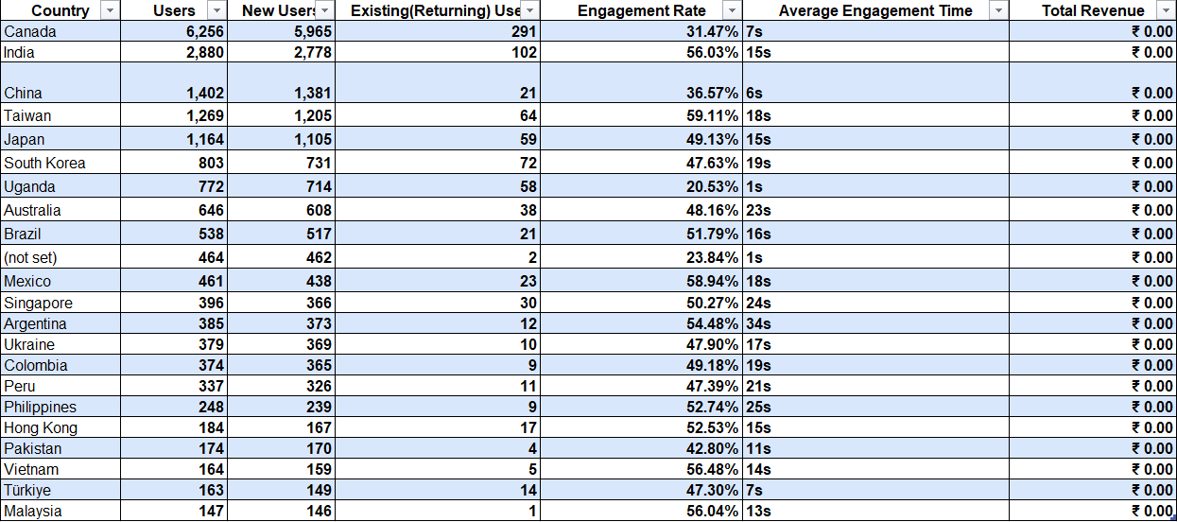

**3.Countries With Revenue: The top-preforming markets**



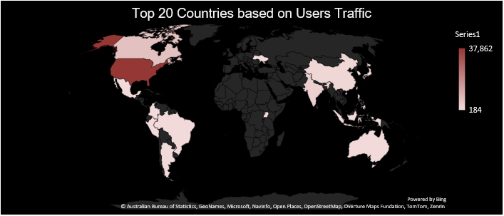

The **United States** is by far the leading traffic source with over **37,000 users**, followed by **India**, **Canada**, and **China**. This map helps identify key markets for user engagement and allows better geo-targeted marketing strategies. Notably, while several countries contribute traffic, many regions like **Brazil, Taiwan, and Mexico** show engagement but **generate no revenue**, highlighting untapped monetization potential.

Countries like **India (56.03%)**, **Taiwan (59.11%)**, **Brazil (51.79%)**, Mexico (58.94%) and **Vietnam (56.46%)** show **strong engagement rates** yet contribute **zero revenue**. This clearly signals a **leak in the conversion funnel**—users are interested and interacting but not purchasing. These countries are ideal targets for optimization through localized offers, language support, payment integrations, or improved checkout flows.

**--8. DEMOGRAPHIC ANALYSIS: INTERESTS**

The most popular user interest segment is **Technology/Technophiles**, followed by **TV Lovers**, **Movie Lovers**, and **Shopping Enthusiasts**, indicating a digitally savvy, entertainment-oriented audience. Niche groups like **Shutterbugs** and **Bargain Hunters** are smaller but may have high purchase intent. This information can help tailor content and ad targeting around tech trends, product launches, or entertainment-based hooks.

Many segments show **strong engagement rates** (above **58%**), such as **Music Lovers (59.62%)**, **Cycling Enthusiasts (58.62%)**, and **Cricket Enthusiasts (58.50%)**, but still generate **zero revenue**. Only **Sci-Fi/Fantasy TV Fans** and **Indie & Alternative Rock Fans** contributed a modest **$144.25** each, despite lower engagement rates (~57%). This suggests that while engagement is high, **monetization is not aligned** with user interests—possibly due to poor product relevance or missing CTAs in these content areas.

Despite high **event activity** across categories like **Technophiles**, **Music Lovers**, and **TV Enthusiasts**, revenue is concentrated in just a few interest groups. This misalignment reveals a conversion funnel issue: users are interacting actively (e.g., clicking, exploring), but **not converting into paying customers**. Consider re-evaluating how offers, products, or CTAs are mapped to these segments to unlock their revenue potential.

**--8. DEMOGRAPHIC ANALYSIS: AGE.**

The **35–44 age group** stands out as the top-performing segment, combining high engagement (**52.96%**) with the **highest revenue ($3,033.79)**. Similarly, **25–34** and **45–54** age groups also show strong engagement rates (above **54%**) and moderate revenue. Notably, **18–24-year-olds** engage reasonably well (**50.95%**) but generate lower revenue (**$401.94**), suggesting they might be more price-sensitive. Meanwhile, **65+** and **55–64** groups show lower engagement and zero revenue, indicating either a mismatch in targeting or usability issues for older users. This chart emphasizes that the **25–44** age band is your most valuable and responsive audience segment for both interaction and conversion.

**--8. DEMOGRAPHIC ANALYSIS: GENDER.**

While **male users (58%)** form the largest portion of the traffic, it’s **females who drive the majority of revenue**—contributing **$3,085.18**, almost **4x more** than males (**$802.77**). Interestingly, the **female segment is only 20%** of total users, yet significantly more valuable. This indicates **higher conversion or purchase intent among female users**, making them a highly profitable segment. The "Unknown" group also contributes to revenue ($1,181.86), but with limited insight for targeted strategies. The data suggests focusing more efforts on engaging and expanding the **female user base**, potentially through personalized content or product curation.

# ***CONCLUSION***

The above details were the valuable insights along with some recommendations for each criterion and metric and outcome of the campaigns ran.

And the following is the Dashboard of the Project:

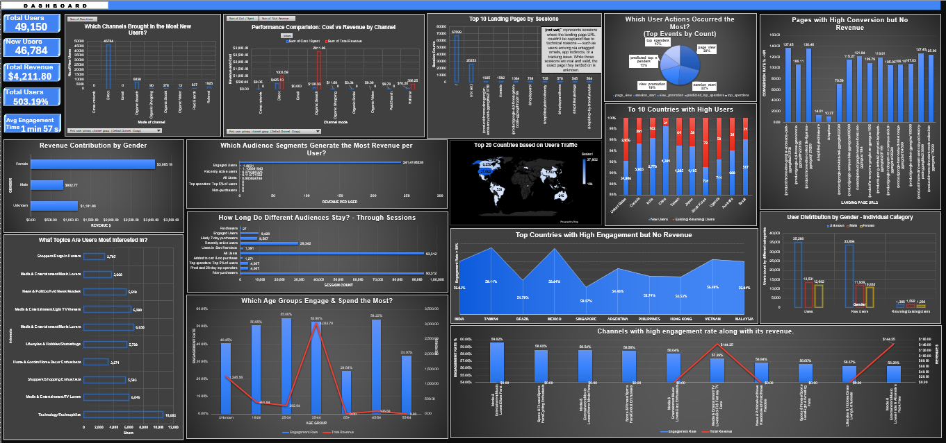

THANK YOU!